Spherical Surface

Definition
# Source: AI Source: Provided by: [Data Path: Persons Table -> ID Column: 1, Name_En Column: Motasem Essam] -> From: [ChatGPT] on [7/20/2026]
A spherical surface is a closed, curved surface in three-dimensional space consisting of all points that are at the same fixed distance from a fixed point called the center.
If $O$is the center and $P$is any point on the spherical surface, then:
$$OP=r$$
where $r$is the radius of the sphere.
Thus, a spherical surface can be defined as:
$$\boxed{\text{Spherical Surface}=\left\{P:OP=r\right\}}$$
A spherical surface represents the boundary of a sphere; it does not include the interior volume.
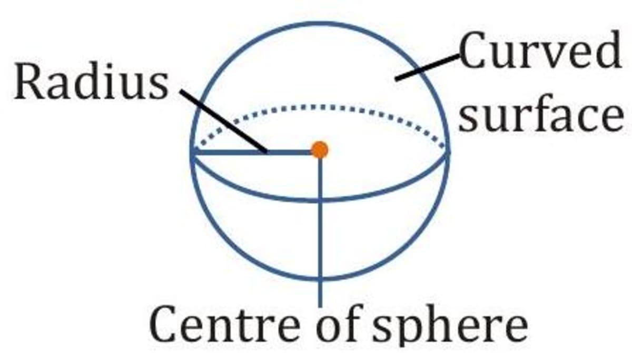
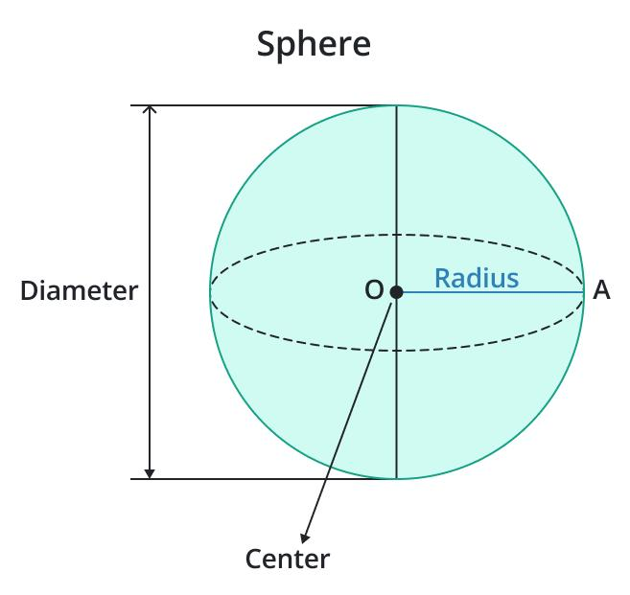
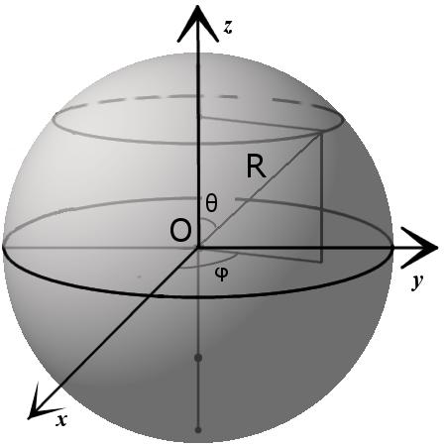

Purpose
# Source: AI Source: Provided by: [Data Path: Persons Table -> ID Column: 1, Name_En Column: Motasem Essam] -> From: [ChatGPT] on [7/20/2026]
A spherical surface is used to:
- Model the boundary of a spherical object.
- Study spherical geometry and three-dimensional geometry.
- Calculate surface area.
- Define the boundary of a sphere.
- Describe objects with spherical shapes.
- Study distances from a fixed center.

Fundamental Elements

1. Center
# Source: AI Source: Provided by: [Data Path: Persons Table -> ID Column: 1, Name_En Column: Motasem Essam] -> From: [ChatGPT] on [7/20/2026]
The center $O$is the fixed point from which every point on the spherical surface is the same distance.

2. Radius
# Source: AI Source: Provided by: [Data Path: Persons Table -> ID Column: 1, Name_En Column: Motasem Essam] -> From: [ChatGPT] on [7/20/2026]
The radius $r$is the distance from the center to any point on the surface.
$$\boxed{OP=r}$$
All radii of the same sphere are equal.

3. Diameter
# Source: AI Source: Provided by: [Data Path: Persons Table -> ID Column: 1, Name_En Column: Motasem Essam] -> From: [ChatGPT] on [7/20/2026]
The diameter $d$is a line segment passing through the center with both endpoints on the spherical surface.
$$\boxed{d=2r}$$

4. Circumference of a Great Circle
# Source: AI Source: Provided by: [Data Path: Persons Table -> ID Column: 1, Name_En Column: Motasem Essam] -> From: [ChatGPT] on [7/20/2026]
A plane passing through the center of a sphere intersects the spherical surface in a great circle.
The circumference of a great circle is:
$$C=2πr$$

5. Great Circle
# Source: AI Source: Provided by: [Data Path: Persons Table -> ID Column: 1, Name_En Column: Motasem Essam] -> From: [ChatGPT] on [7/20/2026]
A great circle is the largest possible circle that can be obtained by intersecting a sphere with a plane.
Every great circle passes through the center.
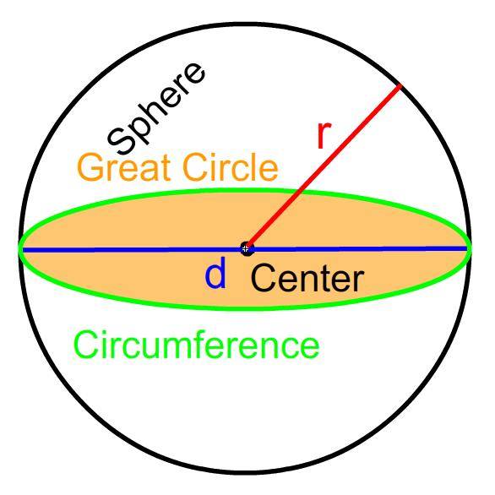
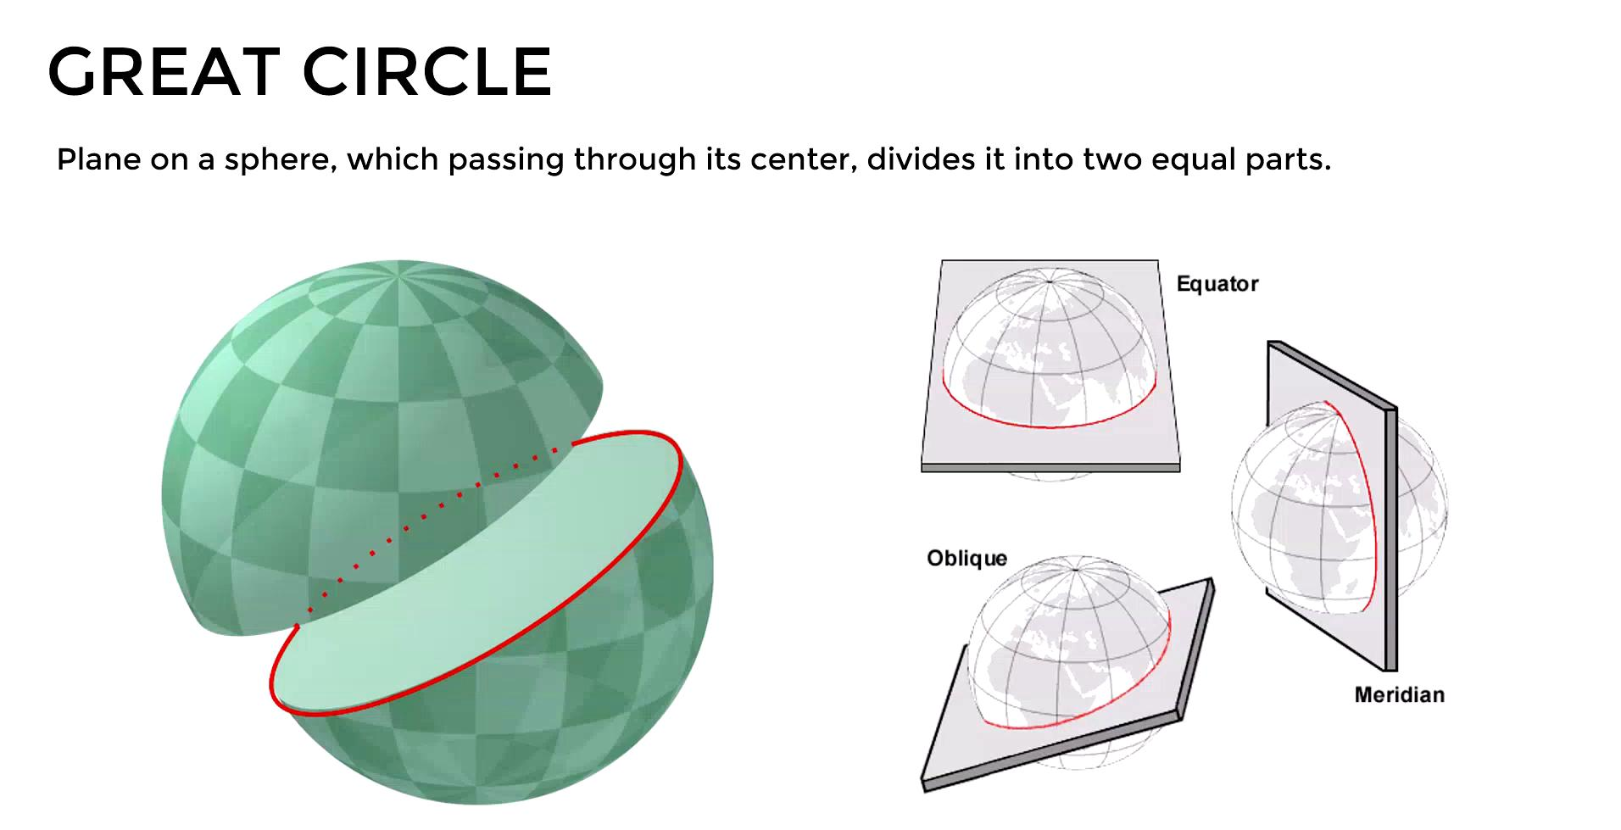
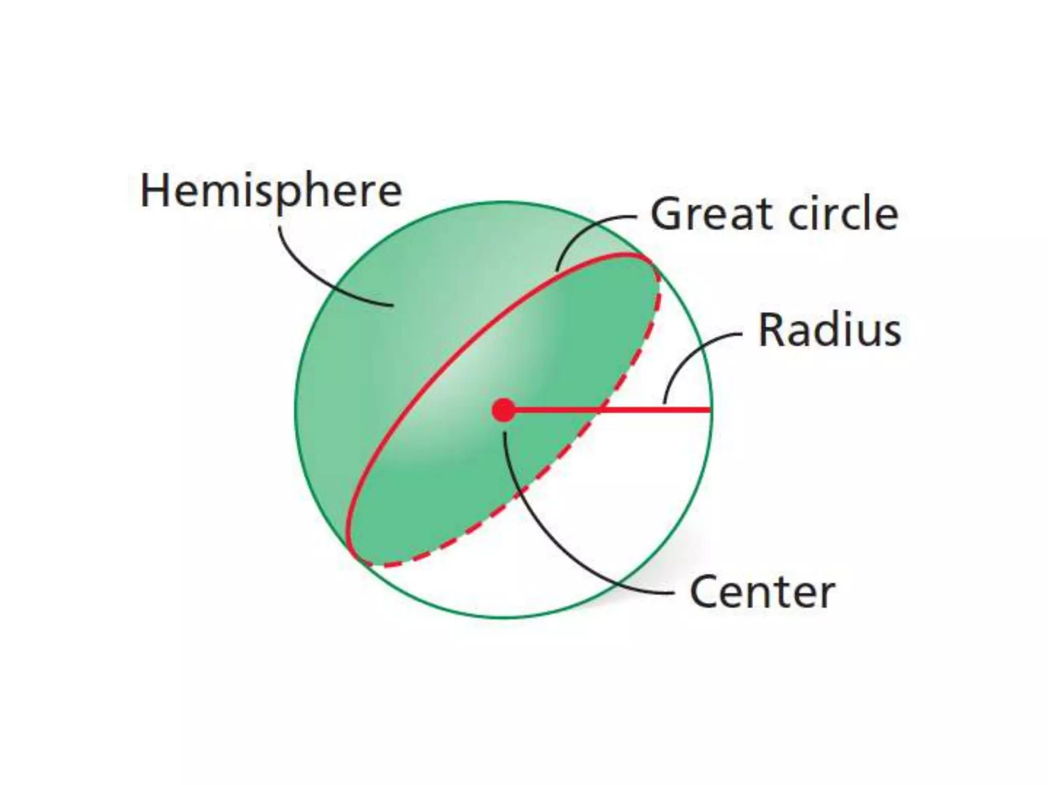
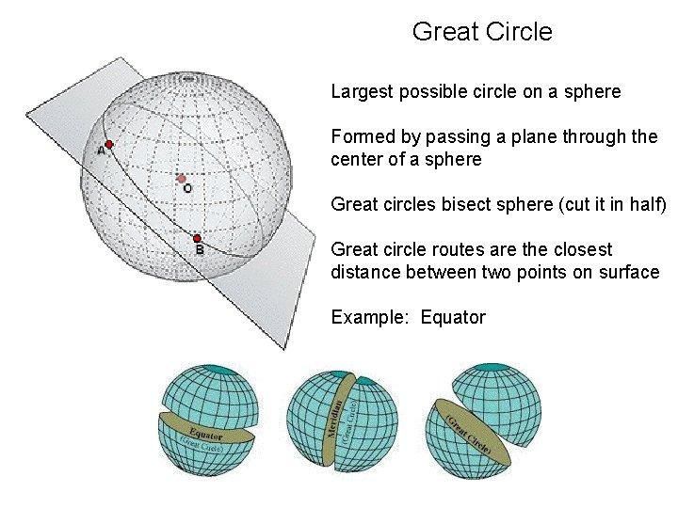
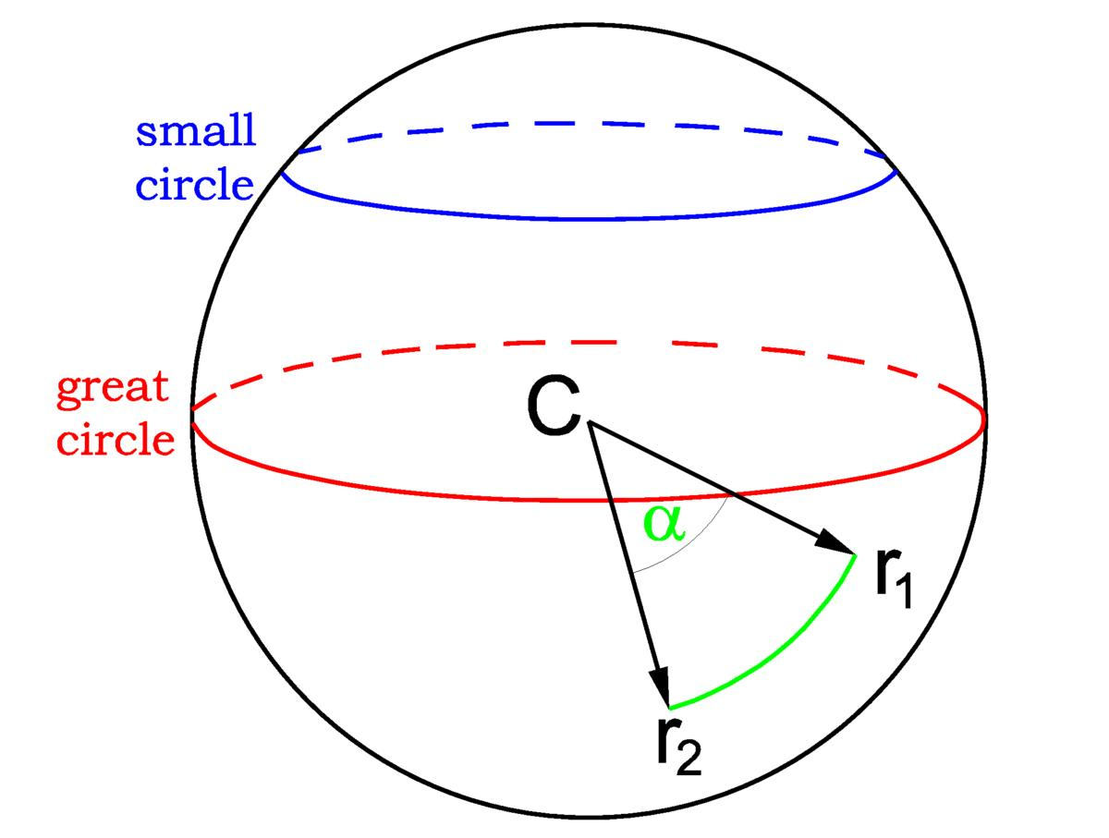

Mathematical Representation
# Source: AI Source: Provided by: [Data Path: Persons Table -> ID Column: 1, Name_En Column: Motasem Essam] -> From: [ChatGPT] on [7/20/2026]
For a sphere centered at the origin with radius $r$, its spherical surface is represented by:
$$\boxed{x^{2}+y^{2}+z^{2}=r^{2}}$$
For a sphere centered at:
$$\left(h , k , l\right)$$
the equation becomes:
$$\boxed{{\left(x-h\right)}^{2}+{\left(y-k\right)}^{2}+{\left(z-l\right)}^{2}=r^{2}}$$
The equality sign is important because this equation represents the surface only.
The corresponding solid sphere is:
$${\left(x-h\right)}^{2}+{\left(y-k\right)}^{2}+{\left(z-l\right)}^{2}≤r^{2}$$

Surface Area
# Source: AI Source: Provided by: [Data Path: Persons Table -> ID Column: 1, Name_En Column: Motasem Essam] -> From: [ChatGPT] on [7/20/2026]
The surface area of a spherical surface with radius $r$is:
$$\boxed{SA=4πr^{2}}$$
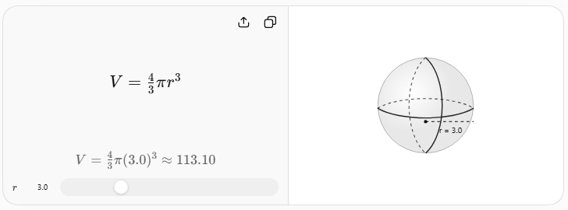
The visualization above shows the related dependence of sphere volume on radius. For the spherical surface itself, the relevant measure is surface area.

Example 1 — Surface Area
# Source: AI Source: Provided by: [Data Path: Persons Table -> ID Column: 1, Name_En Column: Motasem Essam] -> From: [ChatGPT] on [7/20/2026]
Suppose a spherical surface has radius:
$$r=5\text{ cm}$$
Its surface area is:
$$SA=4πr^{2} \\ SA=4π{\left(5\right)}^{2} \\ SA=100π{\text{ cm}}^{2}$$
Therefore:
$$\boxed{SA=100π{\text{ cm}}^{2}}$$
Approximately:
$$SA≈314.16{\text{ cm}}^{2}$$

Example 2 — Diameter
# Source: AI Source: Provided by: [Data Path: Persons Table -> ID Column: 1, Name_En Column: Motasem Essam] -> From: [ChatGPT] on [7/20/2026]
If the radius is:
$$r=8\text{ m}$$
then:
$$d=2r \\ d=2\left(8\right) \\ \boxed{d=16\text{ m}}$$

Example 3 — Finding the Radius from Surface Area
# Source: AI Source: Provided by: [Data Path: Persons Table -> ID Column: 1, Name_En Column: Motasem Essam] -> From: [ChatGPT] on [7/20/2026]
Suppose:
$$SA=144π{\text{ cm}}^{2}$$
Using:
$$SA=4πr^{2}$$
we obtain:
$$144π=4πr^{2}$$
Divide by $4π$:
$$r^{2}=36$$
Therefore:
$$\boxed{r=6\text{ cm}}$$

Important Distinction: Spherical Surface vs Sphere
# Source: AI Source: Provided by: [Data Path: Persons Table -> ID Column: 1, Name_En Column: Motasem Essam] -> From: [ChatGPT] on [7/20/2026]
These terms should not be treated as identical.
Spherical Surface
The spherical surface is only the outer boundary:
$$SA=4πr^{2}$$
Sphere as a Solid
The solid sphere includes the interior and therefore has volume:
$$V=\frac{4}{3}πr^{3}$$
Thus:
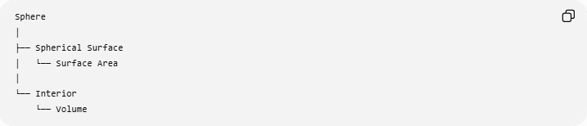
Sphere
│
├── Spherical Surface
│ └── Surface Area
│
└── Interior
└── Volume
A useful mathematical distinction is:
$$x^{2}+y^{2}+z^{2}=r^{2}$$
→ spherical surface
while:
$$x^{2}+y^{2}+z^{2}≤r^{2}$$
→ solid sphere.

Properties of a Spherical Surface
# Source: AI Source: Provided by: [Data Path: Persons Table -> ID Column: 1, Name_En Column: Motasem Essam] -> From: [ChatGPT] on [7/20/2026]
- It is a curved surface.
- It is a closed surface.
- Every point on the surface is the same distance from the center.
- It has no edges or vertices.
- Its radius is constant.
- Every diameter passes through the center.
- Every plane through the center produces a great circle.
- Its surface area is:
$$4πr^{2}$$
- It completely encloses a spherical volume.
- It has the same appearance in every direction from its center.

Spherical Surface as a Curved and Closed Surface
# Source: AI Source: Provided by: [Data Path: Persons Table -> ID Column: 1, Name_En Column: Motasem Essam] -> From: [ChatGPT] on [7/20/2026]
The classifications from your previous topics can be combined:
$$\boxed{\text{Spherical Surface}=\text{Curved Surface}+\text{Closed Surface}}$$
This is important because curved/plane and open/closed describe different properties.
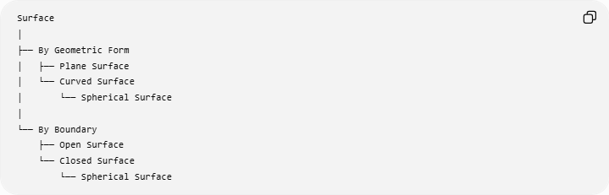
Surface
│
├── By Geometric Form
│ ├── Plane Surface
│ └── Curved Surface
│ └── Spherical Surface
│
└── By Boundary
├── Open Surface
└── Closed Surface
└── Spherical Surface
Therefore, a spherical surface belongs to both classifications:
- Curved → because it bends.
- Closed → because it has no boundary and completely encloses a region.

Spherical Surface vs Other Curved Surfaces
# Source: AI Source: Provided by: [Data Path: Persons Table -> ID Column: 1, Name_En Column: Motasem Essam] -> From: [ChatGPT] on [7/20/2026]
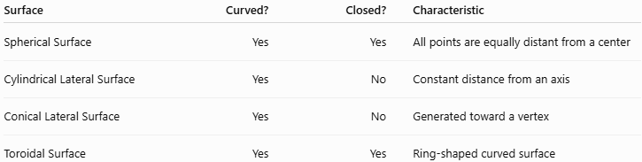
Surface | Curved? | Closed? | Characteristic
Spherical Surface | Yes | Yes | All points are equally distant from a center
Cylindrical Lateral Surface | Yes | No | Constant distance from an axis
Conical Lateral Surface | Yes | No | Generated toward a vertex
Toroidal Surface | Yes | Yes | Ring-shaped curved surface
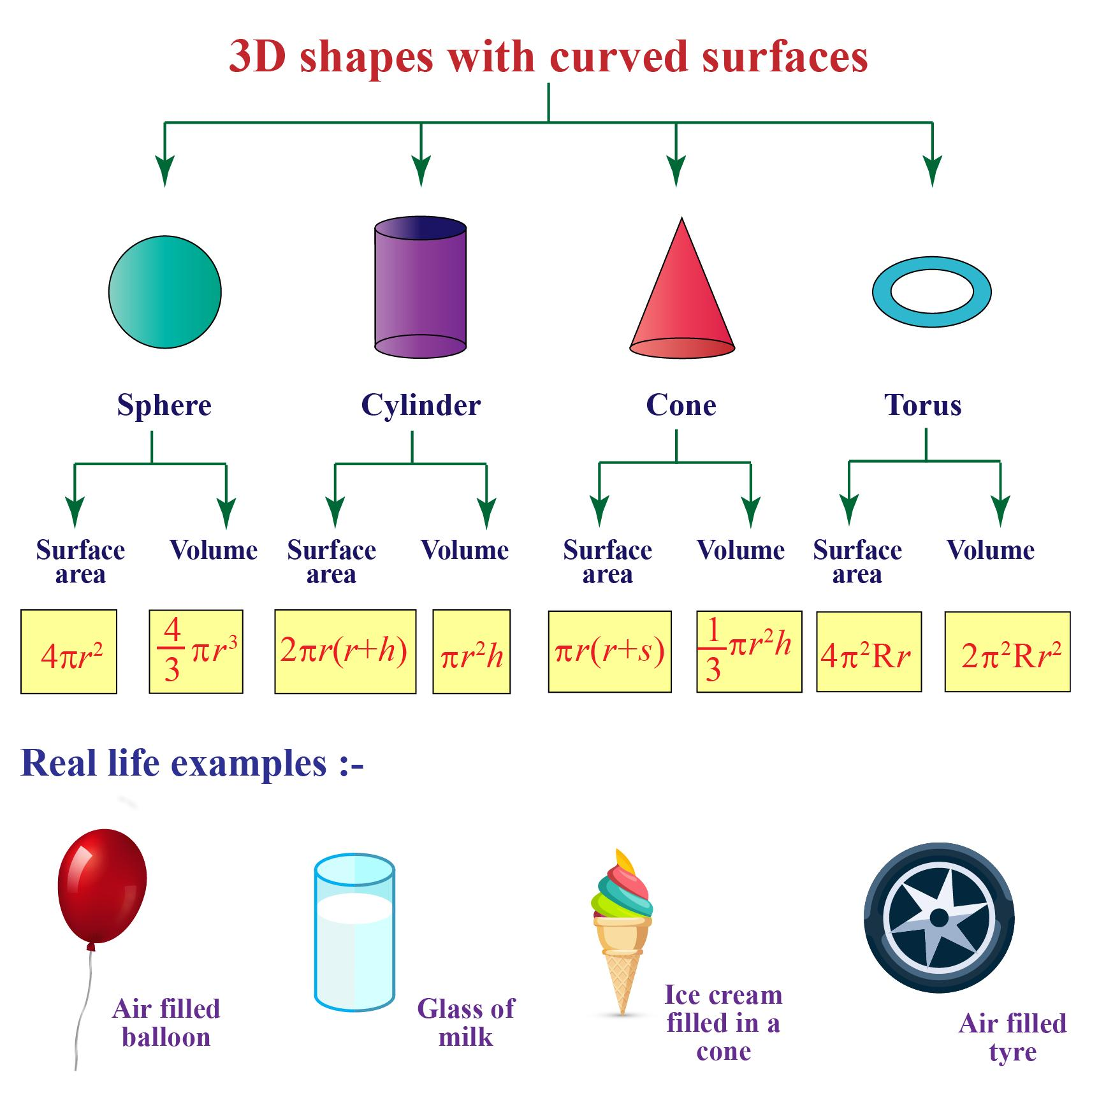
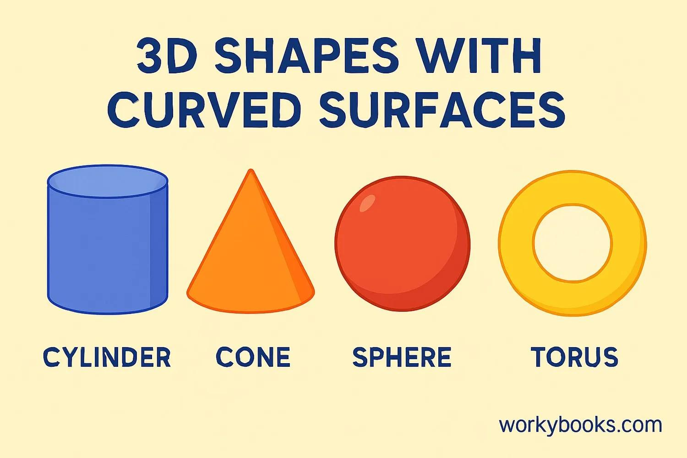
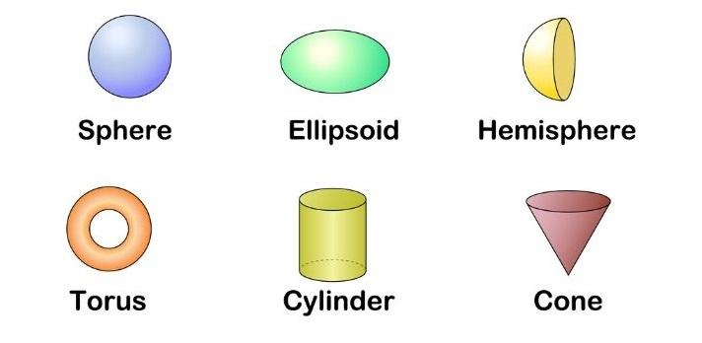

Real-World Applications
# Source: AI Source: Provided by: [Data Path: Persons Table -> ID Column: 1, Name_En Column: Motasem Essam] -> From: [ChatGPT] on [7/20/2026]
Spherical surfaces are used to model:
- Balls
- Globes
- Planetary surfaces
- Spherical tanks
- Domes
- Bearings
- Spherical lenses
- Radar domes
- Astronomical bodies
- Satellite components
For example, planets are often approximated as spherical objects, although their actual surfaces are not perfect mathematical spheres.

Relationship with Related Concepts
# Source: AI Source: Provided by: [Data Path: Persons Table -> ID Column: 1, Name_En Column: Motasem Essam] -> From: [ChatGPT] on [7/20/2026]
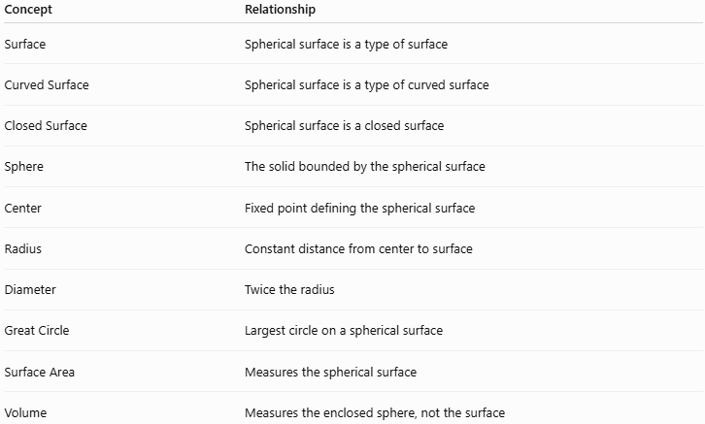
Concept | Relationship
Surface | Spherical surface is a type of surface
Curved Surface | Spherical surface is a type of curved surface
Closed Surface | Spherical surface is a closed surface
Sphere | The solid bounded by the spherical surface
Center | Fixed point defining the spherical surface
Radius | Constant distance from center to surface
Diameter | Twice the radius
Great Circle | Largest circle on a spherical surface
Surface Area | Measures the spherical surface
Volume | Measures the enclosed sphere, not the surface

Key Points
# Source: AI Source: Provided by: [Data Path: Persons Table -> ID Column: 1, Name_En Column: Motasem Essam] -> From: [ChatGPT] on [7/20/2026]
- A spherical surface is the set of all points at a constant distance from a center.
- Its defining relationship is:
$$\boxed{OP=r}$$
- It is both curved and closed.
- It has no edges or vertices.
- Its diameter is:
$$d=2r$$
- Its surface area is:
$$\boxed{SA=4πr^{2}}$$
- A plane through the center creates a great circle.
- The equation of a sphere's surface centered at the origin is:
$$\boxed{x^{2}+y^{2}+z^{2}=r^{2}}$$
- A spherical surface should be distinguished from a solid sphere.

Conclusion
# Source: AI Source: Provided by: [Data Path: Persons Table -> ID Column: 1, Name_En Column: Motasem Essam] -> From: [ChatGPT] on [7/20/2026]
A spherical surface is a closed curved surface in which every point is the same distance from a fixed center. It is one of the most important curved surfaces in geometry and provides the mathematical boundary of a sphere. Its fundamental measurements include radius, diameter, great-circle circumference, and surface area.

